

Emergency Salvage Plan Template
Collections Incident Hotline No XXXX XXXXXX
Press Hotline No XXXX XXXXXX

Phoenix House
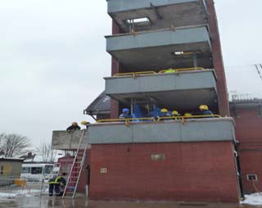

West Midlands FRS training Centre
Dartmouth Road Smethwick
West Midlands

Post Code: B66 1BG
Grid Reference: SE 50595 07044

Telephone Number of Site: 0121 380 6620

Date of Writing Plan: 04/01/2010

Person Writing Plan: Bob Bantock

Manual No. 1 of 3

To be kept at:
Copy also located at: Desks in Lecture Room A

Revision Number & Date: Rev 4 01/05/15 Salvage Lists Updated
Call Out lists Update

Emergency Evacuation Procedures

IN CASE OF FIRE OR OTHER EMERGENCY:

Raise the alarm by breaking the nearest fire alarm break-glass call point
- Evacuate the premises by the nearest route
- Tackle the fire, if trained and safe to do so, without taking any risks.
- Call the Fire Brigade by dialling 999

ON HEARING THE ALARM

  - Evacuate the premises by the nearest route
  - ensure that disabled people are helped to safety
  - Report to the assembly Point at

<In the Car Park>

DO NOT

Do not stop to collect personal belongings
- Do not re-enter the building until authorised to do so
- Do not use lifts unless disabled
& lift is checked and declared safe to use.

Emergency Response

Assess Evacuation Procedure (on inside cover) Call Out Procedure
Internal Contacts
External Contacts

React Command Structure for Emergencies
Site Plan Floor Plans Floor Hazards
Risk Assessment for Salvage Operations Entry Control Log

Guidance Notes on:
  - Fire
  - Flood
  - Security
  - Spillage
  - Documentation & Security of Salvaged Objects
  - Dealing with the Media

Inventory of Priority Objects Salvage Sheets
Inventory of Salvaged Objects – Blank Form

Protect First aid treatment – guidance on:
    - Air Drying
    - Books
    - Ceramics
    - Freezing
    - Furniture
    - Leather
    - Metal
    - Mould
    - Natural History
    - Paintings
    - Paper
    - Photographs
    - Plastic
    - Stone
    - Textiles
    - Packing Items

Recover Salvage Recovery Areas - Salvage Store Contents List -
Post Incident Procedure



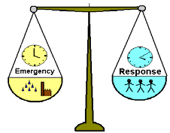

OUT OF HOURS INCIDENT RESPONSE
Date of amendment

Phoenix House
West Midlands Fire Academy Dartmouth Road
Smethwick
West Midlands B66 1BG Telephone: 0121 380 6620

INCIDENT OCCURS

Are the

Dial 999
Directions/ Fire Access: inc. out of hours access

Site Keys: where are site keys kept? Who has access?

emergency services required immediately?
Yes

No
Essential Contacts (e.g. Property manager/area manager/building surveyor as applicable)
Name/ job role | Contact numbers work/mobile/home | Distance from site
Name/ job role | Contact numbers work/mobile/home | Distance from site
Name/ job role | Contact numbers work/mobile/home | Distance from site
- Trust Press Hotline: 0207 ??? ????
- If collection is at risk call the General Manager on???? ????

Do you need to contact alarm or security companies?

Yes
 | Monitoring Station | Maintenance Company | Reset arrangements | Contract Information
Fire Alarm | Name and contact details | Name and contact details
Security Alarm | Name and contact details | Name and contact details
Panic Alarm | Name and contact details | Name and contact details
Other  eg.CCTV,  nightguard, | Name and contact details | Name and contact details

No

Are immediate building works/repairs required?

Yes
Building Surveyor/ Contractor | Company name | Contact details (inc. out of hours/emergency numbers)
M & E Maintenance Contractor | Company name | Contact details (inc. out of hours/emergency numbers)
If needed, escalate to:
NT Head of Building | Name | Contact numbers work/mobile/home
NT Regional Director | Name | Contact numbers work/mobile/home

- Record all incidents, accidents and near-misses
- Report all building works to
the relevant team..
During office hours
Property Helpdesk | Contact number | Email address

Emergency Response Plan locations

1.

2.

Essential site information

5-10 bullet points to include:
- size of site
- number of buildings
- type and size of collection
- areas of particular importance/sensitivity/risk
- hazards
- Contact details for others on site, eg. holiday cottage/tenants/other 3rd parties

Organizations and Businesses for use in an emergency

Emergency services | Emergency number (24hrs) | non-emergency number
Ambulance | 999
Fire Services | 999
Police | 999
Environmental emergency | 0800 807060
Counter Terrorism hotline | 0800 789 321
RAYNET radio services | 0303 040 1080
Utilities | Emergency number | non-emergency number
Electricity
Water
Gas
Local Government contacts | Emergency number | non-emergency number
Floodline (24 hrs) | 0845 988 1188
The British Damage Management Association  (BDMA) | 07000 843 2362 | www.bdma.org.uk
Health Protection Agency | 01235 822603/742 | www.hpa.org.uk
National Flood Forum | 01299 403055 | www.floodforum.org.uk
CIRIA (Flooding advice) | 020 7549 3300 | www.ciria.org/flooding
The Construction Centre (Flood products & Services) | 01926 865825 | www.theconstructioncentre.co.uk
Trades people | Emergency number | non-emergency number
Electrical (A L H Gridley)
Building (Steve Williams Property Maintenance)
Plumbing (Columbus Heating And Plumbing)
Drainage (IWJS)
Fire Alarm System (ADT)
Other Useful contacts | Company name/contact name | non-emergency number
Environment Agency | Duty contact | 07800 555xxxx
Coast Guard | Duty contact | 07800 556xxxx
English Heritage | Duty contact | 07800 557xxxx
Other contacts | Company name/contact name | non-emergency number
Local village hall bookings
Local community council leader
Local community secretary
Parish Council Leader

INITIAL CONTACTS |  | MOBILE | OFFICE | HOME | Distance from home  to site (if appropriate)
Duty Manager Pager |  | 00000 123456
Contact Name | Facilities Manager | 01111 123456 | 00000 111222 |  | Lives on site
Contact Name | Site Manager | 02222 123456 | 00000 222333 |  | Lives on site
Contact Name | Site Supervisor | 03333 123456 |  |  | Lives on  site
Contact Name | Site Team Member | 04444 123456 | 00000 333444 |  | 10 mins
Contact Name | Curator | 05555 123456 | 00000 444555 | 00111 123456 | 30 mins
Contact Name | Conservator | 06666 123456 | 00000 555666 |  | 1 hour
Conservation Incident Hotline | Collections Care 24 hrs | 07785 ?????
NT Press Office | 0207 ??? ????

SITE STAFF/ STAFF BASED AT SITE |  | MOBILE |  |  | HOME | Distance from home to site (if  appropriate)
 |  | MOBILE |  | Office | HOME | Distance from home to site (if  appropriate)
Name | Position (eg. Team Member)
Contact Name | Facilities Team Member | 07777 123456 | 00000 666777
Contact Name | Housekeeper | 08888 123456

Internal Emergency Contact List

OTHER CONTACTS |  | MOBILE | OFFICE | HOME
Head Office |  |  | 0000 1234567
Contact Name | Building Surveyor | 09999 123456 | 00000 777888
Contact Name | B&CE Technical Manager | 11111 123456 | 00000 888999
Contact Name | Head Gardener | 22222 123456 | 00000 999000
Contact Name | Health & Safety ORBP | 33333 123456 | 00000 000111
Contact Name | Regional Director | 44444 123456 | 00000 111222
Contact Name | Office Manager | 55555 123456 | 00000 222333
Contact Name | Senior Curator (Collections) | 66666 123456 | 00000 333444
Contact Name
Contact Name

OTHER SITES
All other useful Trust contacts
L&SE
Grosvenor Gdns
Heelis | 00000 666777
Northern Ireland | 00000 777888

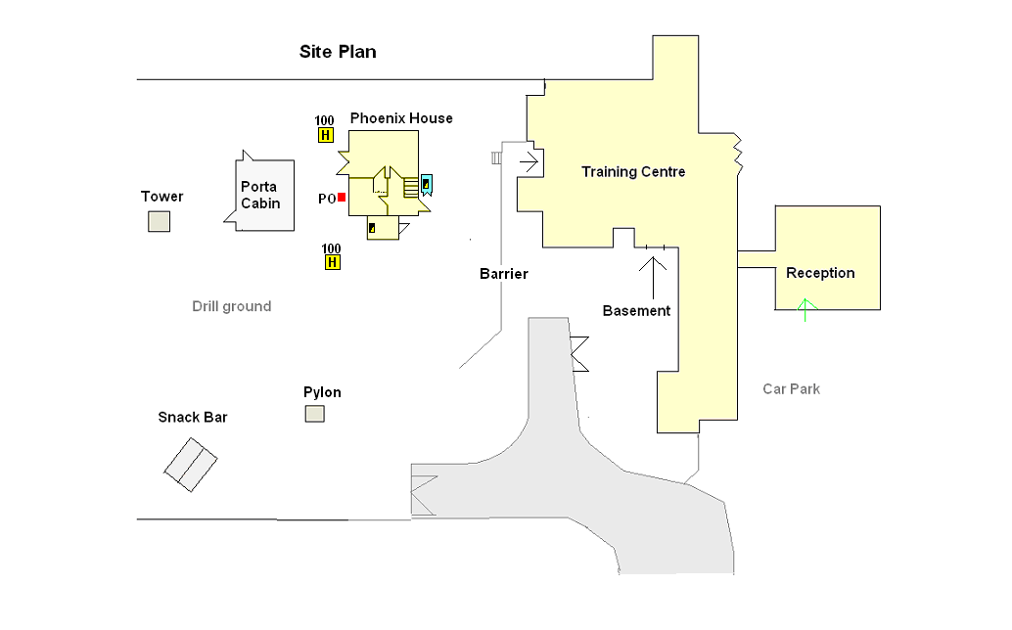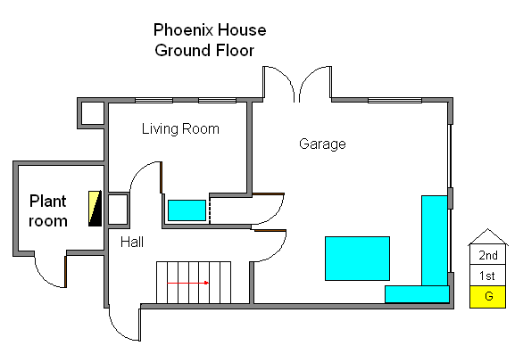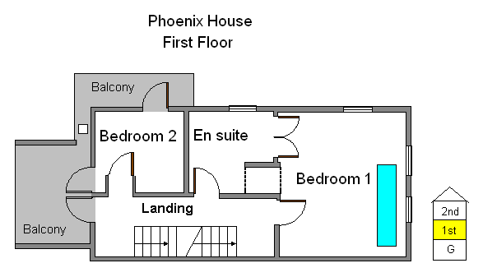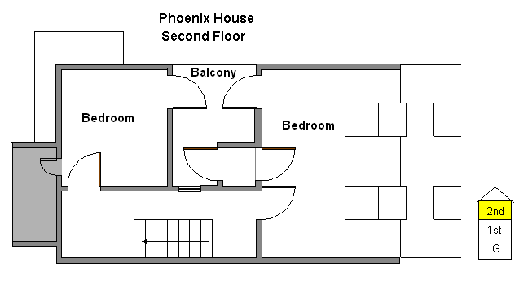

Risk Assessment for Salvage Operations
What To Check For | Satisfactory Condition? |  |  | Describe Hazard | Proposed Action against No or Don’t Know
What To Check For | Yes | No | Don’t Know | Describe Hazard | Proposed Action against No or Don’t Know
Is there effective liaison and communication with emergency services?
Have hazardous Areas Been cordoned off?
Has a Control Point been established?
Has a secure salvage area been designated and secured (as well as possible)?
Have staff been reminded to be alert to security issues, such as theft from
salvage area or unauthorised entry
into the building?
Where applicable, have site security guards been re-deployed?
Is there record of who is in emergency area, where they are working? & when they are due to return to control point
Is there an evacuation procedure in place?
Is there a system in place to identify hazards & warn operatives?
Is there a system in place to ensure operative’s welfare & to guard against fatigue?
Is there a system in place to ensure good manual handling practices?
Is Personal Protective Equipment available & used when required?

TIME | Description of event / telephone / radio message
  INCIDENT COMMUNICATIONS RECORD
  INCIDENT LOG
  Date: | Name of Recorder: | Sheet No: ……of……

INCIDENT COMMUNICATIONS RECORD

Entry Control Log
Date: | Name of Recorder: | Sheet No: ……of……

TIME IN | NAME | No. | TIME OUT

Entering a Burning Building in Safety

The Senior Fire & Rescue Service Officer is in Charge !

Do not enter inner cordon unless you have been briefed and know:

- where the fire is & there is no danger of being trapped.
- what your specific task is & you are capable of undertaking it.
- your personal protective equipment is suitable & sufficient.

If you satisfied with the above:

Sign in the entry log

Stay with your buddy or team
Be aware of your surroundings at all times. Breathe only fresh air not smoke
Check doors are not warm before opening them
Keep escape route within sight Keep to job in hand, do not wander Listen for evacuation whistle
Stay in radio contact (if available)

Sign out of the entry log

Danger Signs

Sudden increase in temperature, noise or smoke production Collapsing roof timbers
Fire on floors below you

Remember

The exit route & any alternatives
Smoke rises so if caught, crawl on the floor in fresh air

The evacuation signal: - short blasts on a whistle

Before entering a flooded building, consider:-

Electrical hazards
Structural hazards
Hazardous materials
Bacteria and viruses
Ventilation

Electrical hazards

If water has come into contact with electrical circuits, and especially if the water rose above electrical outlets, turn off power at the main breaker or fuse of the service panel. Do not turn power back on until the equipment has been repaired or inspected by an electrician.

Structural hazards

Never assume that water-damaged structures, particularly ceilings, are safe. If in doubt DO NOT ENTER. Leave immediately if shifting or unusual noises signal a possible collapse.

Hazardous materials

Damaged building materials may contain asbestos and lead-based paint. Before disturbing suspect material, precautions should be taken to prevent exposure. Floodwaters can contain hazardous materials such as pesticides, fuel or spilled chemicals. Play it safe and do not enter if in doubt.

Bacteria and viruses

Microscopic organisms, particularly those from sewage, can be found in mud or sediment left by floodwater. If you accidentally swallow sediment or flood water that is contaminated, you might develop gastrointestinal illness. You can reduce the risk by wearing rubber gloves, not eating or smoking, and frequent hand washing. If you get a cut or wound that is exposed to flood water, there is some risk of tetanus and you should be vaccinated if you haven’t received a tetanus vaccination within the past 5 years.

Ventilation

Do not use petrol or generator pump within an enclosed area as there is a danger of carbon-monoxide poisoning.
Entering a flooded building in safety

Dealing with the media fact sheet

- Dealing with the media – phone calls

All media requests from journalists and television companies should be referred to National Trust. Here’s some advice on what to do if you get a call from a journalist at your site or office.

There is no such thing as a friendly journalist!
They are all, almost without exception, friendly and charming people but they are also professional people for whom friendship might jeopardise their integrity or give the perception of doing so!

Think before you speak
Don't say anything you don't really mean - not even as a joke.

Always be polite
Journalists have deadlines and can be under severe pressure to file a story. If you can’t help by answering their question directly try to do so in an understanding way:

‘I can see your problem but...life must be difficult for you on this story but....’

Assume everything you say is on the record
You might need to say that you are going to tell them something for background or operational reasons, but always consult Corporate Communications before doing so. In practice, there’s no such thing as ‘off the record’.

Be careful about simple denials or ‘yes’ answers
Journalists might put a long and rambling question to you and then when you say ‘yes’, attribute it as a quote from you. It is unrealistic to ask for editorial control or copy approval, but it is perfectly reasonable for you to ask for any quote they have taken from you to be read back to you.

You don't have to answer questions in the terms they are put
A reporter will put something to you in negative terms such as ‘why is National Trust doing it this way? Etc. It is your job to answer as positively as possible. Say something like ‘we know that over 70% of our members are satisfied with our progress....’

Dealing with the media – broadcast interviews

  - Prepare yourself. National Trust Communications will help you rehearse and prepare a set of anticipated questions and their answers. The Trust is fortunate in having a large number of leading experts. Nerves cannot usually destroy genuine knowledge, but if you don't know your stuff, waffle will show you up. Try to think of every possible angle.
  - Determine the three points you want to make and get them over as soon as you can. Whatever the interviewer's question, try and turn it on
to your ground. For example:

‘That's an interesting question, but can I first put it to a bit of context?

  - If you can think of a soundbite, use it!
  - Remember to say ‘National Trust ’ as often as you can rather than ‘we’.
  - Make sure you know the exact conditions negotiated for you by Corporate Communications.
  - Is it live or pre-recorded? Can you take something again if you are not happy? Who else is on? Can you hear what they have said? Will you get the last word? What is the tone of the programme? Does your contribution come after a filmed report?
  - Try and use plain language. Don’t use abstractions, latin or jargon.
Use short sentences and try and remember to keep things simple without being patronising or ‘dumbing down’.
  - If you have said what you wanted to say, shut up.
  - It is not up to you to keep the conversation flowing. Don't be lured in to saying more!
  - Hair and make-up are important. Try not to be too distracted if you are unused to make-up. Let the make-up department do their job!
  - Avoid jangly jewellery and too many layers of clothing around the neckline. It is also best to avoid small patterns such as stripes, spots
and checks, especially herringbone as they dazzle on TV.
  - For male staff, a shirt and tie is normally the safest option. Some very stylish people get away without a tie, but they have usually been ‘styled’ by a professional or dressed very expensively.
  - Sit up straight in the chair. The back of a tailored jacket can ride up making you look hunched.
  - Wear dress that is appropriate on site interviews
  - Remember to smile, but not too much or you will not be believed.
  - Never wear sunglasses for an outside interview.
  - Check there is nothing visually distracting behind you

First Floor Red Bedroom
Priority 1
Japanese Ceramic Vase Inventory no: 45.1950
45cm  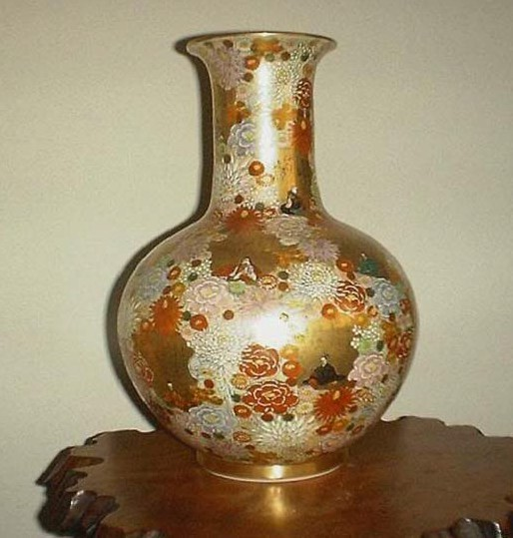 |  | 65cm
Removal:
- Hold carefully from base.

Object First Aid Record
Wet or Damp | Contam inated | Broken | Weak | Dangerous to Handle | Mouldy | Smoke Damaged | Other

Pack As Is | Dry  and Pack | Keep Wet  and Freeze | Wash then  Dry | Other

Inventory of Salvaged Objects

Object Type | Inventory No (if  known) | Object Description/s | Floor & Room Recovered from | 1st Aid Rqrd?  Where | Returned form 1st Aid? | Pack  ? | Crate? Wrap? Ref Number | Where Stored?
EXAMPLE ONLY | 90002454  5 | 8 blue vases | FR4 Dining Room | No | EXAMPLE | Yes | Crate 1 | Brodsworth Barn 1
EXAMPLE ONLY | 90017777 | Small painting Horse Racing | Billiard Room | No | EXAMPLE | Yes | Crate 3 | Momart Receipt 00114
EXAMPLE ONLY | - | Children on swing | FR4 Dining Room | Yes wet | EXAMPLE |  | Item ref FR4 P1

Object Type | Inventory No (if known) | Object Description/s | Floor & Room Recovered from | 1st Aid Rqrd? Where | Returned form 1st Aid? | Pack  ? | Crate? Wrap? Ref Number | Where Stored?

Object Type | Inventory No (if known) | Object Description/s | Floor & Room Recovered from | 1st Aid Rqrd? Where | Returned form 1st Aid? | Pack  ? | Crate? Wrap? Ref Number | Where Stored?

Object Type | Inventory No (if known) | Object Description/s | Floor & Room Recovered from | 1st Aid Rqrd? Where | Returned form 1st Aid? | Pack  ? | Crate? Wrap? Ref Number | Where Stored?

Object Type | Inventory No (if known) | Object Description/s | Floor & Room Recovered from | 1st Aid Rqrd? Where | Returned form 1st Aid? | Pack  ? | Crate? Wrap? Ref Number | Where Stored?

AIR-DRYING

- Air-drying involves objects being spread out over an area and dried through air movement or dehumidification.
- This method of drying can be carried out in-house. It is cheap, but labour intensive and requires space.

PREPARE ROOM
- Remove any wet materials i.e. stationary, boxes, curtains or carpet.
- Open windows and bring in fans to circulate air OR close all windows and use dehumidifiers. (Ensuring damp air or water is vented/ drained out of room.)
- The drying effect can be intensified with a wind tunnel, a tunnel of Correx or plastic sheeting with fans at one or both ends (Ensure air from fans is not aimed directly at fragile items.)
- Washing lines can be put up for hanging or pegging (using plastic pegs) strong, but damp sheets of paper.
- Plastic, perforated racks such as bread trays or airing racks are ideal for air drying objects as they provide support and allow airflow.

RINSING
If the objects are heavily soiled, the worst of the dirt can be removed by brushing or rinsing off, taking care not to introduce dirt to clean areas, i.e. keep books shut.

PREPARE OBJECTS
- Assess books and paper based material first. (Heavily waterlogged books should be frozen if possible)
- Treat books in the following order:
weak and wet books
weak and damp books
strong and wet books
strong and damp books
- Consider the fragility of paper and fastness of dyes.
- Support all areas of fragile items, either on a board or by holding together loose fragments with a gauze bandage.
- Remove paper clips, string or ribbon (and keep bagged and labelled) to prevent staining or stress on the object.
- Three dimensional objects such as costumes and baskets need to be padded out to their normal shape before air drying. Nylon netting can be used for this
- Books that are strong enough can be stood on their spines and the pages fanned out. Turn them up the other way after a while. See ‘Books’ sheet for other options.
- Flat items such as maps, newspapers, documents and plans can be dried flat between blotting paper, as long as the inks are not running. Change blotting paper regularly.

Typical Store Inventory
6 Dustbins and lids | 3 Gaffer tape | 2 x 240v Spare Bulbs
1 Squeegee | 6 brown tape | 2 Adaptors for 240v lights.
1 Broom | 6 waterproof tape (Powerstick) | 150 Bin bags -(heavy)
1 Shovel | 3 hazard warning tape | 6 Carrying Straps
Sack trolley (3 wheeled variety) | 3 webbing tape (Black) | 6 Reams Tissue Paper
Turntable truck | 2 webbing rolls | Sides and Fittings for Pop-up Shelter
Plastic bowl for Hand washing and 2 bars soap | 2 petrol cans (empty) | 35 Plastic Carrying Bags
2 Hand torches | 1 x 50m extension lead for generator | 5 Salvage Sheets and two floodlight tri-pods
3 Rolls of Bubblewrap | 1 Hard back writing book | 6 Reams Blotting Paper
13 sheets of Plastazote, + offcuts | 5 Clipboards+pads | 40 Sorbarix Pads
3 rolls of heavy, & 3 rolls of medium polythene | 5 biros | 2 x Tool bags each with
Boxes - flat pack 15 x lidless, 9 x with lids | 2 scissors | bolt croppers
Generator 4 Kva | 4 boxes of freezer bags | crowbar
Wet Vac (Prepared for wet suction) | 2 staple guns | hammer large
Submersible Pump c/w hose. | 1 boxes of staples | 1 pliers
1 Ladder (Combi )1 Step Ladder (8 treads) | 1 stanley knive pack | 1 pincers
1 Instant Pop-Up Shelter | 2 balls of string | 2 hacksaws with 2 spare blades
1 Folding Table | 6 indelible marker pens | 1 X 5 metre tape
Wet Vac (Prepared for wet suction) | rubbers | 1 adjustable wrench (300mm)
Submersible Pump c/w hose. | pencils | 7 screwdrivers (various)
4 waterproof suits | small stapler +staples. | 2 Stanley Knives
4 tyvec suits | 500 Inventory tags | 1x 14inch handsaw
4 hi viz waistcoats | 500 Adhesive labels
4 safety kit (gloves, goggles, mask) | 3 Absorbent paper rolls
4 pairs gripper gloves | First aid kit
6 safety helmets | 2 Spare torch batteries
6 dust sheets | 4 x 240v Floodlights 1 x 240v Free standing Light
6 ropes (50m) | 4 x 240v Floodlights 1 x 240v Free standing Light
Post Incident Procedure
1 PURPOSE OF THIS PROCEDURE

The purpose of this procedure is to detail the method of making the site ready for occupation after a fire, alarm activation, or other emergency.

2 COMPETENCIES REQUIRED TO CARRY OUT THIS PROCEDURE

Staff must be familiar with the site or building, the normal opening up procedure, and what devices or equipment that might need to be reset after activation of the fire alarm system.

3 WHEN TO USE THIS PROCEDURE

Staff must use this procedure after the site has been made safe following a fire, fire alarm signal or other emergency. If the incident has caused anything more than minor damage the re-opening may need to be delayed to allow for a comprehensive clean-up or building repairs.

4 WHAT YOU NEED TO DO

- If visitors are waiting for entry keep them informed as to what is happening
- Reset the fire alarm system
- Check that all exit doors and routes are free from obstructions and other hazards; clean or otherwise rectify as necessary.
- Cordon off any areas that are hazardous and cannot be made safe.
- Open automatic fire doors that are held open on magnets.
- Check that all areas are adequately lit.
- Ensure that the visitor experience will not be unduly affected
- Restart boilers.
- Check that room stewards are in position
- Staff the tills
- Allow entry

