Bronze level (small) emergency scenario

You are a museum in the centre of a Yorkshire city housed in an 18th century building.

It is 03:00, a coffee machine in the cafe has had a fault causing it to leak water. The water has come through the ceiling into the photographic room where a number of items where waiting to be photographed.

The items include:
An armour on a stand
Five firearms on a table, one with bone inlay
A painted metal helmet on a stand
An 18th century pen and ink drawing of armour decoration

Only the security team is in the museum and they have rung you to tell you about the problem. What should you do?

To respond to this situation:
- What can you tell security to do before you get there?
- What will you do when you arrive?
- What handling issues may you have to be aware of?
- What health and safety considerations will there be?
- What materials and equipment will you get?

What rules will you establish to guide your response? What issues will guide the response?

Resources:

You have an emergency kit with lights, extension, materials such as blotting paper, plastic sheeting, mops, buckets etc. You also have a chest freezer that is used for pest control.

Bronze level emergency scenario response: facilitator’s notes

Before you arrive
- Switch of water
- Switch on chest freezer
- Ask them to get emergency kit and trolley ready
- What you can ask may depend on the training they have had

On your arrival
- Speak to person who found situation and get overview
- Carry out risk assessment
- Set up lights
- Set up table in dry area
- Remove the drawing first as most at risk, using plastic sheet
- Remove other objects
- Place drawing on blotting paper or wrap for freezer? (check with Sharon)
- Air dry other objects
- Do not pat dry painted helmet
- Lay weights on inlay to stop them lifting

H&S
- Risk assessment
- Check if near lighting using tourches
- Check ceiling looks safe
- Check floor in case slippy
- Wear appropriate foot wear
- PPE (at least gloves)

Handling
- How is the armour attached to stand? Will any thing fall off if you lift it?
- Avoid touching painted surface on helmet
- Be careful not to catch inlay on firearm with gloves

Equipment and materials
- Plastic sheeting
- Blotting paper
- Freezer just in case
- Fan
- Weights

Silver level (moderate) emergency scenario

You are a small independent archive in the centre of a North Yorkshire market town. The archive is housed in an early 20th century building rented from the local authority. It is staffed by a Director, a General Manager and 8 long-standing volunteers.

There has been a fire in the late afternoon in one of your stores caused by faulty wiring. Some painted wood panelling has smouldered but the fire was detected by smoke alarms early on and contained by the Fire Brigade. The entire room and its contents are covered in a ‘greasy’ sooty deposit and the air smells acrid but the store’s contents are not water damaged. The lights do not work due to the electrical damage.

The store houses 2 filing cabinets of administrative material and some small drawers with old card indexes as well as the following on open powder coated shelves:
- 50 (unboxed) 19th century cloth and leather pattern books
- 60 boxed manuscripts and printed material
- 200 19th and 20th century books

It is winter and outdoor temperature and relative humidity are low.

To respond to this situation:
- What health and safety considerations will there be?
- What external agencies and help will you need?
- What staff input do you require?
- What space will you need?
- What materials and equipment will you get?

What rules will you establish to guide your response? What issues will guide the response?

Resources:

AN ACCOUNT OF THE CONSERVATION AND PRESERVATION PROCEDURES FOLLOWING A FIRE AT THE HUNTINGTON LIBRARY AND ART GALLERY Barbara Roberts et. al. JAIC [Journal of the American Institute for Conservation] 1988, Volume 27, Number 1, pp 1-31

http://cool.conservation-us.org/coolaic/jaic/articles/jaic27-01-001_indx.html

THE FIRE AT THE ROYAL SASKATCHEWAN MUSEUM, PART 1: SALVAGE, INITIAL RESPONSE, AND THE IMPLICATIONS FOR DISASTER PLANNING Sarah Spafford-Ricci, Fiona Graham JAIC 1988, Volume 39, Number 1

http://cool.conservation-us.org/jaic/articles/jaic39-01-002_3.html

Silver level emergency scenario response: facilitator’s notes

H&S
- Switch off air con. to stop spread of smoke
- Get clearance from Fire Officer to enter
- Ventilate if possible (be aware of exterior RH above about 50% and security if opening windows)
- Risk assessment (some risk assessment can be done in advance)
- PPE (e.g. respiratory, skin, eye protection) - soot can contain hazardous chemicals
- Hazard tape/no touching signs/restricted access
- Lighting (generator needed)
- Maintenance of electrics prior to fire as part of risk management
Externals
Fire Service; electrician; landlord; loss adjustors (building AND collections affected); conservators; volunteers and temporary staff; networks (e.g RRN); trustees/important donors; possibly a commercial recovery firm (insurers may appoint one but not all firms are appropriate for heritage collections- though they may be ok for non collections material–so check their credentials before the emergency)
Staff input
- Clear roles needed so that focus is maintained and decisions expedited fast (no deviating from the specific roles) with good team working/communication; liaison with landlord’s camp v. important
- Pastoral support for staff – the damage can be devastating
- Lots of people required for cleaning soot– options could include conservator who trains volunteers [these could extend beyond the regular ones] and temporary staff and/or a specialist recovery firm; salvage priorities would be dictated by uniqueness/value so pattern books and manuscripts (if damaged) then books – replacement rather than salvage of books could be considered; consider disposal/retention of admin/card index material
Space
- Secure and dry (‘clean’ and ‘dirty’?) temporary stores and treatment area, preferably on-site (items will have to be moved to allow clean-up of damaged store)
Materials/Equipment
- PPE (e.g. Tyvek suits, overshoes, respirators with particulate filter and goggles or head top respirator, nitrile gloves)
- Crates and dollies
- Extension cord
- Generator and lamps
- Museum Vacuums with HEPA filter
- Smoke sponges (AKA chemical sponges)
- Tables and plastic sheeting for clean-up
- Refuse sacks (spent cleaning material may be considered ‘special waste’); documentation both written and photographic (for recording removal, treatment etc)
Issues
- Landlord/building (potential conflict with collections salvage priorities; care over chemicals used in clean-up of building – landlord likely to use commercial company); need for all to understand conservation issues so liaison crucial
- Security (there will be many interested parties on-site, at least initially)
- Funds for supplies and services etc need releasing quickly
- PR (using PR in early stages to get donations etc; media contacts, internet etc)
- Communications external/ internal (lots of agencies and individuals will be involved)
- Business continuity
- Conservation issues -
  - Handling – no touching until initial vacuum; care with handling/moving/cleaning so as not to increase the damage
  - Need to act within weeks as soot gets harder to remove
  - Soot can be acidic (try to limit RH rises to reduce risk)
  - Smoke constituents –may need analysis
  - No ozone to deoderize collections; conservators can advise on deoderizing small batches
______________________________________________________________
Silver level emergency scenario response: participants’ notes
H&S
- Turn off electricity
- PPE (masks, gloves, safety shoes etc)
- Generator, lights, extractor
- Air into building
- Get public out/don’t let public back in
Externals
- Electricians | - Volunteers
- Insurers | - RRN
- Conservators | - Security people
Staff input
Manager and Director; 4 volunteers
Space
- Another room within the building for storage and a midway point for cleaning; temporary storage containers
Materials/Equipment
- Boxes and crates
- Cages
- Trolleys
- Polythene
- Freezer bags [no need for freezing as damaged materials are not wet – dry removal of soot needed]
- Lights
- Generator
- Cleaning equipment
- Tea, coffee, (chocolate) biscuits
- Stationery – removal forms and labels

Gold level (large) emergency scenario
Queensland Art Gallery flood

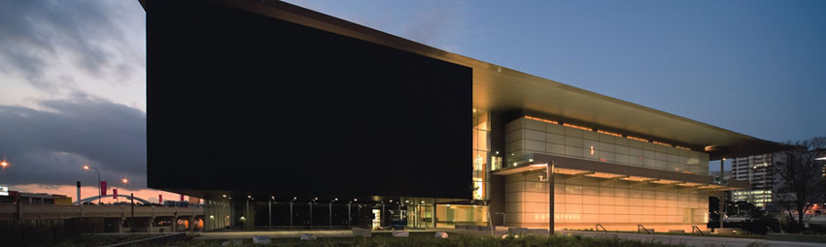At Queensland Art Gallery, you have 24 hours warning that flood water will inundate your area. Many of the collections should be out of reach of the water, being on upper levels, but there are some temporary exhibitions and loans that are at risk- the international and Australian collections on the lower level of the building, including current featured exhibitions Scott Bedford: Introducing Reinhardt Dammn and Vida Lahey: Colour And Modernism.
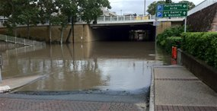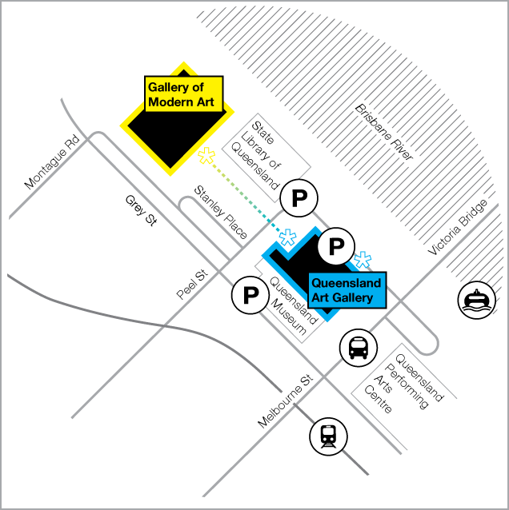
The car park is on a low level

To respond to this situation:
- What health and safety considerations will there be?
- What external agencies and help will you need?
- What staff input do you require?
- What space will you need ?
- What materials and equipment will you get?
- What rules will you establish to guide your response?

Gold level emergency scenario response: facilitator’s notes
http://www.abc.net.au/news/stories/2011/01/12/3111440.htm
moved things up a level
using twitter and facebook
humidity
power cuts

