[insert name here]
Emergency Plan

Version [insert number here]
Date[insert date here]

Copy number: [x] of [y]

To be kept at: [insert recognisable place here]

If found, please return to [insert name and address]

[Friendly advice about your emergency plan –
- Get it right. 2. Keep it up to date. 3. Keep it to hand. 4. Make sure people know about it.]
[Replace or delete everything in [ ] with your own text. There should be no [ ] in your final version.
This note should be deleted!]
Contents |  | Page

SECTION ONE What you need to do
1 | Introduction | 3-4
2 | The three types of emergency | 5
3 | What to do in an emergency (overview) | 6
4 | What does the Emergency Leader (EL) do? | 7
5 | What does the Salvage Manager (SM) do? | 8
6 | What does the Business Manager (BM) do? | 9
7 | What do you need if you are an Emergency Volunteer? | 10

SECTION TWO Useful information
8 | Names and phone numbers – emergency response team | 11
9 | Contact details for Emergency Volunteers | 12
10 | Accommodation for recovery operation | 13
11 | Emergency contacts | 14
12 | Using the Rapid Response Network | 15
13 | Useful numbers for local suppliers | 16
14 | Insurance details | 17

SECTION THREE Useful forms and equipment
15 | Incident assessment form | 18
16 | Contents and locations of our emergency kits | 19
17 | Contents of Rapid Response Network kits | 20

SECTION FOUR – Site plan, photographs and priority lists

These photographs and lists cover Priority One Objects only
18 | [Building name] site plan, photographs and priority lists | 24

[Don’t forget to alter the page numbers as appropriate]
[Get rid of the lines by clicking on no borders in the drop down borders menu]

- INTRODUCTION

Use this plan when there is an emergency.

Who uses this plan, and when?
If you respond to an emergency, you must use this plan.
It will guide you through the first few hours of an emergency.

[Insert names or roles] in the buildings where we have collections [or use building names] must be told about procedures to follow if there is an incident.

What is an emergency?
An emergency is any incident which threatens human safety and /or damages or threatens to damage or destroy the museum’s [change if appropriate] buildings, contents, facilities or services. The most serious threats arise from fire or flood. Other threats arise from terrorism, vandalism, theft, gas leaks or infestation

Who decides if this is an emergency?
During opening hours [insert full name or role] will decide whether a situation is minor (green), major (amber) or serious (red).

During closed hours the decision will be taken by whoever answers the alarms. They will take control.

Where are the copies of this plan?
Copies of the plan are held in the following locations
- [insert as many locations as appropriate]

Don’t consult this plan when the public are present, as it contains sensitive information.

Personal copies are held by [insert full names]. If you have a personal copy, keep it in a secure location because of its sensitivity. You must bring your copy with you if you are called in during closed hours.

The master copy of this plan, copies of the building plans and copies of the priority lists are kept in [insert secure location here].

How do we keep this plan up to date?
This plan is version [insert number ], issued in [insert month/year ]. We will review it [insert month/year ] or if the plan is activated before then. We will then review it annually. Before we issue revised versions (versions 2, 3 etc), we will recall all these copies, to ensure that everyone uses the same version.

[insert full name or role ] is responsible for updating this Emergency Plan.

Training
Staff and regular volunteers will receive training in the contents and purpose of this plan within eight weeks of its issue, and annually thereafter. Staff will also receive basic training in what to do in the event of an emergency. [insert full name or role] is responsible for organising this training.

Improving this plan
We welcome any suggestions for improving this plan. If you have any ideas, please contact [insert full name or role].

Health and safety
[insert organisation name here] is committed to ensuring the safety and security of its staff, volunteers and the public at all times. As such, this plan is coupled with a risk management programme to reduce the likelihood of an emergency incident.

At no stage is anyone expected to put themselves in danger. [insert full name or role] will ensure that health and safety is properly assessed and adequate personal protective equipment (PPE) is provided. Staff and volunteers are expected to use PPE, as instructed by the Emergency Management Team.

Other plans
This Emergency Plan is a companion document to other plans and manuals

The [insert plan name] contains ‘Alarm Procedures – opening hours’ and ‘Alarm Procedures – outside opening hours’.

The [insert plan name] deals with the aftermath of an emergency, not the emergency itself. It includes guidance on salvage, especially for the collections.

The [insert plan name] deals with commercial aspects after an emergency.
- THE THREE TYPES OF EMERGENCY

There are three types of emergencies – green, amber and red.

GREEN - minor
A minor emergency might be:
- A small fire that is quickly contained and extinguished using a fire extinguisher
- A small flood caused by a slow leak from a pipe or radiator
- Minor water ingress from heavy rain (but not sewage, sewage is never minor)
- An attempted burglary with no actual entry into the building

AMBER - major
This is more serious than a minor emergency but does not need dozens of staff and lots of fire-fighters or police. A major emergency might be:
- Any ingress of water tainted by sewage
- Major water ingress from heavy rain or blocked gutters
- A large flood caused by a leaking pipe or overflowing basin
- A fire that requires the presence of the Fire Service but is quickly and easily extinguished
- The water damage resulting from this sort of fire (although this may become a serious red emergency depending on amount of water used)
- A burglary that damages the building and causes loss of, or damage to, museum / gallery artefacts or shop stock or takings of low value

RED - serious
A serious emergency needs lots of emergency services, many staff and volunteers, and other outside agencies as well. A serious emergency might be:
- A fire that is attended by more than one tender
- A gas explosion or major electrical burnout
- Severe flooding from fighting the fire
- Severe clean water ingress
- Serious flooding, tainted with sewage, and caused by unusually heavy and prolonged rainfall
- A ram raid or armed robbery
- A serious burglary that severely damages the building and causes loss of, or damage to, museum / gallery artefacts or shop stock or takings of moderate or major value

If there is a fire, the fire service will control access to the building

3. WHAT TO DO IN AN EMERGENCY (OVERVIEW)

If an emergency situation is coded Amber or Red then the following rules apply:

- Identify the Emergency Leader
During opening hours the most senior member of staff available will automatically assume the role of Emergency Leader. If they are unavailable another member of the Management Team [insert different group name where appropriate] will take responsibility. Once the nature and scale of the emergency is clear they may decide to hand over leadership to another qualified person.

Outside opening hours the alarm company will contact the first name on their contact list and will go through the list until someone responds. This person will attend the scene and must decide if the incident is a green, amber or red using the list on page 5. If it is amber or red s/he must automatically assume the role of Emergency Leader. Once the nature and scale of the emergency is known s/he may decide to hand over leadership to another qualified member of staff.

- Activate the Emergency Plan
The Emergency Leader will activate the Emergency Plan. S/he will summon the available staff / volunteers [delete as necessary] if appropriate.

- Set up the Emergency Management Team
The Emergency Leader (EL) will nominate a Salvage Manager (SM), and a Business Manager (BM). These three people will constitute the Emergency Management Team. Their roles are explained on the next three pages.

- Call in more volunteers
Depending on the scale and duration of the emergency the Leader may decide to call in other people who have offered to help – the Emergency Volunteers.

- WHAT DOES THE EMERGENCY LEADER (EL) DO?

If you are the Emergency Leader you must
- pick up any building keys you require from [insert place]
- put on appropriate PPE
- ensure that you meet with the SM and the BM regularly and brief them before work on recovery starts
- decide if the emergency is green, red or amber
- find out when access will be possible, if it is not already
- conduct a site tour as soon as possible, using the Incident Assessment Form on page 18 (in Section Three)
- liaise with emergency services if they are present
- set up a control point
- communicate and liaise within the team
- ensure that the priority items are retrieved (see Section Four of this plan)
- call out the Emergency Volunteers, if appropriate, using the list on page 12, Section Three
- tell volunteers that they might be required later, if appropriate
- deal with suppliers
- deal with the council [if this is appropriate for your organisation]
- deal with the Board [replace with appropriate governing body]
- keep in mind the big picture

- WHAT DOES THE SALVAGE MANAGER (SM) DO?

If you are the SM your role depends on whether or not there is access to the building

If access is possible, you must
Assess the situation
- put on appropriate PPE
- assess the incident
- carry our risk assessments
- identify what personal protective equipment people must use
- identify what water testing is needed
- allocate the people present to different teams
Look after the teams
- be responsible for health and safety
- ensure people use appropriate PPE
- organise rest breaks and refreshments
Manage the salvage
- if necessary, organise the removal of items, following the priority lists
- remove or protect Priority One objects first – they are listed in this plan
- if necessary, then remove Priority Two objects – they are listed in [insert here]
- if necessary, then remove other objects
- set up temporary sorting and storage areas for salvaged objects
- install emergency lighting in affected areas
- organise the removal of excess water, using pumps and dehumidifiers
- organise the documentation, sorting and treating of salvaged objects
- decide if building should be closed to public or non-essential staff
Organise support
- decide what equipment, supplies and contractors are needed for the salvage operation
- liaise with someone’s technical staff
- collect the Rapid Response Network kit, if required
- arrange for the insurance company to be contacted, if appropriate

If access is not possible, you must
- prepare an action plan based on the briefings
- organise equipment, suppliers, contractors, and Rapid Response Network kit, as appropriate
- stand down staff not immediately required
- WHAT DOES THE BUSINESS MANAGER (BM) DO?

If you are the BM, you must
- deal with media
- provide information for users
- determine re-opening strategy
- activate business continuity arrangements, using the Business Continuity Plan
- initiate PR plan

- WHAT DO YOU NEED IF YOU ARE AN EMERGENCY VOLUNTEER?

If you are called out as an Emergency Volunteer,

please bring
- your copy of the emergency plan, if you have one
- some cash if you have some (no more than £10)
- your ID
- a mobile phone
- Wellington boots and waterproofs, if you have them
- a torch
- a flask with a hot drink and something to eat

please wear
- warm clothes
- stout shoes
- glasses rather than contact lenses

on site, you must
- follow the instructions of the Salvage Manager
- wear appropriate Personal Protective Equipment (PPE), which will be provided

DO NOT TALK TO THE PRESS OR THE MEDIA

- NAMES AND NUMBERS - OUR RESPONSE TEAM

For an emergency at [names of any site where you have collections]

During office hours
(Monday – Friday 8.30am - 5.00pm)

Name | Tel No - Office Hours | Job Title

Outside Office Hours
(after 5.00am and before 8.30pm in the week, all weekends, and all Bank Holidays)

Name | Tel No - Home | Mobile No | Tel No - Work | Travel time | Travel method

[these tables need completing]

- CONTACT DETAILS – EMERGENCY VOLUNTEERS

The following staff, and volunteers have agreed to act as Emergency Volunteers in the event of an amber or red alert. They should only be contacted if a member of the Emergency Management Team authorises this.

Name | Internal | Home | Mobile | Travel time | Travel method

[this table needs completing]

Rapid Response Network

Members of the RRN have agreed to help each other in an emergency.
We can therefore ask for help from other organisations that are also members of the RRN.

Contact details for all these organisations are on the RRN members’ only website.

Website name - rrn.vintagecarriagestrust.org
Our user name – [insert]
Our password – [insert]

- ACCOMMODATION FOR RECOVERY OPERATION

Assembly Area
Where people will gather when called in
Control Point
Private, with phones and IT
First Aid Point
Sorting Area
Large area in central location
Storage for unaffected material
Secure area
Treatment area
Large area with good ventilation
Packing area
Near loading bay or entrance
Contractor parking

[this table needs completing]

- EMERGENCY CONTACTS

Contacts for the Emergency Services

In an emergency, dial 999 for the police and the fire service.

If you smell gas, call 0800 111 999.
Don’t create a flame or operate electrical switches.
Do put out flames, open doors and windows, keep people away from the area and turn the gas off at the control valve.
[only include this if you have gas in your building]

If it’s not an emergency, contact the police on [insert number].
[insert name of nearest] Police Station is staffed [insert times].

Contacts at the Council and the Board [adapt as necessary]

Job Title | Name | Telephone Number | Responsibilities
Head of Tourism and Culture Services |  |  | Council’s tourism and cultural services
Conservation Officer |  |  | Buildings preservation
Communications Officer |  |  | Council’s Press and communications
IT Manager |  |  | IT support
Telecoms Manager |  |  | Broadband

[this table needs adapting / completing]

See page 17 for details of our insurance.
12. USING THE RAPID RESPONSE NETWORK

We are members of the Rapid Response Network. The RRN keeps emergency equipment and materials at four [change to five when Northallerton opens] depots, which we can borrow and use for free. The nearest depot is at [insert name here] .

There is a list of all the RRN equipment on pages 20-23 in Section Three.
Take it with you when you go to the depot.

If you want to use a kit, contact the person listed below.
Arrange a time with them when you can collect some or all of the kit.
Rapid Response Network Training Programme
Kit location contacts
Name | Organisation |  |  | Daytime Telephone | Storage location
Nial Adams /  David Marchant | Beverley Museum  Available 24/7  Out of hours contacts: Nial Adams 01482 874893 / 07880 735967; David Marchant 01482 887469 |  |  | 01482 392770 / 01482 392771 | Archives store, The Treasure House, Beverley, HU17 8HE
Dale Keeton / Gavin Edwards | Shipley Store, Bradford Museums  Available 24/7  Out of hours contacts: Dale Keeton 07794 284468 / 01535 669380; Philip Mann 01274 583899 |  |  | 07582 100744 (Dale), and 07582 100379 or 01274 431212 (Gavin) | Unit 33-35, Back Saltaire Road North, off Saltaire Road, Shipley, BD18 3HR  The turning off Saltaire Road is opposite the Aagrah restaurant.
Paul Graham | Rotherham Museums  No out of hours access |  |  | 01709 336632 | Store adjacent to Art Gallery, Rotherham Arts Centre , S65 1JH
 |  | Dave Whitehead / Paul Beaumont / Helen Metcalfe / Steve Taylor | Yorkshire Sculpture Park  (One is always working in opening hours)  No out of hours access | 01924 830631 or 0777 543 1314 (Dave), 01924 830586 (Paul), and 01924 830727 or 0779 052 5642 (Helen and Steve) | Longside Gallery, Yorkshire Sculpture Park, WF4 4LG. Always contact main YSP site first as Longside has no full-time on-site staff. Longside is c.1 mile from main YSP site, up Jebb Lane, 1st road on left on A637 towards Huddersfield past J38 M1.

[Amend this when Northallerton opens]

Other members of the Rapid Response Network may volunteer to help us in an emergency. They may also provide temporary storage space or access to freezers and other equipment.

Contact details are on the RRN website – see page 12.
13. USEFUL NUMBERS FOR LOCAL SUPPLIERS

Business | Name | Tel No | Out of Hours Number
Joiner
Lift engineer
Locksmith
Plumber
Electrician
Gas fitter
Window repairs
Security
Skip hire
Scaffolding
Staff hire
Cleaners
Removals
Catering

[this table needs adapting / completing]
14. INSURANCE DETAILS

Buildings and contents

Our buildings and contents are insured by [insert name].
Our Policy Number is [insert number]

[insert name] looks after this insurance policy.
They are based at [insert place] on [insert phone number].

Equipment and public liability

Our equipment and public liability insurance is arranged by [insert name].
Our Policy Number is [insert number]

[insert name] looks after this insurance policy.
They are based at [insert place] on [insert phone number] .
15. INCIDENT ASSESSMENT FORM

Use this form to work out what kind of emergency it is

Incident Assessment Form
What is the nature of the damage?
Fire, smoke, water, sewage, other

When did the incident happen?

Which areas are affected?
Check the entire building

What types of things are affected?
Collections, equipment, stock

Are priority items involved?

What are the environmental conditions?

What possible health and safety issues are present?

How much material is affected?
Number of boxes or metres of shelving

How extensively has water penetrated into cabinets or boxes?

Is there power, water and heat?

Are telephones working?

Is our emergency kit accessible?

Are any areas of the building in a suitable condition to open?

16. CONTENTS AND LOCATIONS OF OUR EMERGENCY KITS

Our Emergency Kits are kept

At [insert building name]: in [insert recognisable location name]

Each kit contains:

[Stationery
6 ballpoint pens, 6 waterproof pens, 3 clipboards, 4 notepads, a pack of Tyvek tags, a ball of string, a pack of box label pockets

Tape
6 rolls of parcel tape, and a roll each of masking tape, hazard tape, ‘Fragile’ tape and Glass tape

Packaging
A roll of black sacks, a roll and a pack of polythene sheeting, a pack of polythene bags, a plastic box

Paper
A pack of silicone paper, a roll of newspaper, a pack of blotting paper

For mopping up
3 Sorbarix cushions, a box of absorbent material, a sponge, a soot sponge, a pack of disposable cloths

Tools
3 craft knives, a torch with batteries

Personal Protective Equipment (PPE)]
A pack of disposable aprons
2 packs of masks
8 overalls (2 XXL, 2 XL, 2 L, 2M, 2S)
6 hi vis tabards (2XL, 2L, 2M)
2 boxes of nitrile gloves (1L, 1M)
8 pairs of rubber gloves (2XL, 2L, 2M, 2S)
3 safety hats (1 red, 2 white)

All kept in a red wheely bin, which can be used for internal transport]

[This is a perfectly good list, left here as an illustration.
MAKE SURE YOU DELETE IT AND REPLACE IT WITH YOUR OWN].
17. CONTENTS OF RAPID RESPONSE NETWORK KITS

Mark the items that you want and take this list with you when you go to the RRN kit depot.

 | Rapid Response Network: stock list at each storage location
Crate No | Items in crates | Quantity
1 | Safety signage, assorted, plus folding cones | Various
1 | Hazard warning tape | 1
2 | Cotton gloves (mixed sizes) | 30 pairs
2 | Nitrile rubber gloves | 100 pairs
2 | Safety mask / dust masks | 10
2 | Half mask respirator | 6
3 | Small handy baskets / plastic trays | 10
3 | Nylon netting for textiles, 1m wide | c. 2.6m
3 | PH strips | 100
3 | Garden netting, for lying out items to dry | I small roll
3 | Mini grip bags 9x12ins | 200
3 | Mini-grip bags 5x7ins | 200
3 | Mini-grip bags 4x6ins | 200
4 | Fan heater | 1
4 | Clothes pegs & roll of garden twine | Pack of 36
4 | Polypropylene string | 2
5 | Crepe bandages | 3
5 | Safety pins, pk of 144 | 1
5 | First aid box | 1
5 | Blanket | 4
6 | Large brush & pan | 2
6 | Heavy duty bin liners | 2 or 3 rolls
6 | Spare mop heads | 2
6 | Sponge | 5
6 | Water spray bottle | 2
7 | Dish cloths | 10
7 | Floor cloths | 10
7 | Acid free tissue sheets, 500x700, pk of 500 | 1 pack
7 | Capillary matting | 4m
8 | T shirts | 6 of 12
8 | Hard hats | 4 of 6
9 | Tool box with screwdrivers, pliers, hammer, wirecutters | 1
9 | Retractable knife and blades | 12
9 | T shirts | 6 of 12
9 | Hard hats | 2 of 6
9 | Bungee elastic ropes, to secure loads | 6
10 | Hi vis waistcoat | 6
10 | Headlight & batteries | 3
10 | Safety goggles | 6 of 10
10 | Tyvex suit, assorted sizes | 5
10 | Disposable plastic aprons | 100
10 | Gauntlet work gloves | 3 of 6 pairs
10 | Disposable overshoes | 100
11 | Cable ties | 200
11 | Blotting paper high wet strength, 500x700, pk of 50 | 1 pack
11 | Clipboard | 5
11 | Marker pens, assorted pack | 2
11 | A4 pad, pack of 5 | 1
11 | Scissors, assorted pack of 3 | 1
11 | Garden twine | 1
11 | Self adhesive labels | 250
11 | Parcel tape | 2
11 | Duck tape | 2
11 | Tie on labels with string | c.40
11 | Tyvek tags | c.250
11 | Tyvek pens | 12
11 | Pencils | 36
11 | Waterproof pens | 24
11 | Carbon paper, pk of 10 | 4
11 | Brown paper roll, 500mmx6m | 3
11 | Numbered ID forms | 200
11 | Pre-printed forms – recovery | 50
11 | Pre-printed forms - risk assessment | 50
12 | Paper towels, case of 500 | 1
13 | Lay flat tubing, to knot into small bags | 1 roll
13 | Tarpaulin sheet | 2
13 | Polythene sheets, 2 gauges | 4
14 | PVC Gauntlets (long) | 2 pairs
14 | General purpose rubber gloves | 5 pairs
14 | Waterproof suits, mixed sizes | 6
15 | Gauntlet work gloves | 3 of 6 pairs
15 | Safety goggles | 4 of 10
15 | Circuit breaker rcd adapter | 2
15 | Wrecking bar / crowbar | 1
15 | Hack saw and spare blade | 1
15 | Wind up torch | 1
15 | Wind up lantern | 1
15 | Heavy duty steel dolly / wheels | 2
 | Tools not in crates
 | Electric submersible self-priming pump (240 volt), hose & hose clip | 1
 | Emergency lighting kit 240 volts | 1
 | Emergency lighting kit 110 volts | 1
 | Petrol generator | 1
 | Sponge mop [spare heads in crate 6] | 2
 | Oil spill response kit (15 litre) | 1
 | 25m 240 volt extension reel | 2
 | 25m 110 volt extension reel | 1
 | Sledgehammer | 1
 | Shovel | 1
 | Fuel can | 1
 | Dehumidifier | 1
 | Wet & dry vacuum cleaner | 1
 | Fan | 2
 | Folding table, double fold | 1
 | Folding chairs | 2
 | Handling materials not in crates
 | Trolley truck, collapsible - | 1
 | Sack truck folding | 1
 | Collapsible vented crate | 5
 | Collapsible solid crate | 5
 | Duracrate storage box, interlocking lid, 40 litres | 15
 | Cleaning items not in crates
 | Bucket, 13.5 litre | 2
 | Broom | 2
 | Bowls | 10
 | Conservation materials not in crates
 | Flat pack archival boxes | 20
 | Absorbent flood sacks @: £7 each | 100
 | Bubble wrap roll, 100mx500mm | 2
 | Plastazote, 3mm, 1mx1.5m | 4
 | Tyvek sheeting roll, 20m | 2
 | Acid free tissue (pack) – in crate 7 at some depots | 1
 | Acid free blotting paper (pack) – in crate 11 at some depots | 1
 | Safety clothing / H&S not in crates
 | Step ladder, to reach stored kit | 1
 | Wellington boots, safety, mixed sizes | 6
 | Larger safety signs | various
 | Protection not in crates
 | Correx fluted polypropylene, 2.4x1.2 sheet x 4mm | 5
 | Gazebo (2 bags) | 1

18. [Insert building name here]

FLOOR PLANS

PHOTOGRAPHS OF PRIORITY ONE OBJECTS AND THEIR LOCATIONS

LISTS OF PRIORITY ITEMS

[
]

[Included for illustration only. PLEASE DELETE and replace with one which shows your building]

[Make sure
- you show all the floors of your building
- the rooms on the plan have the same numbers / names that you use on your priority list
- all the things in the key are actually marked on the plan]
Priority One, sheet 1 of [insert number], [insert building name]
[insert floor][insert room name / number]
[this is room 4 on the priority list following]

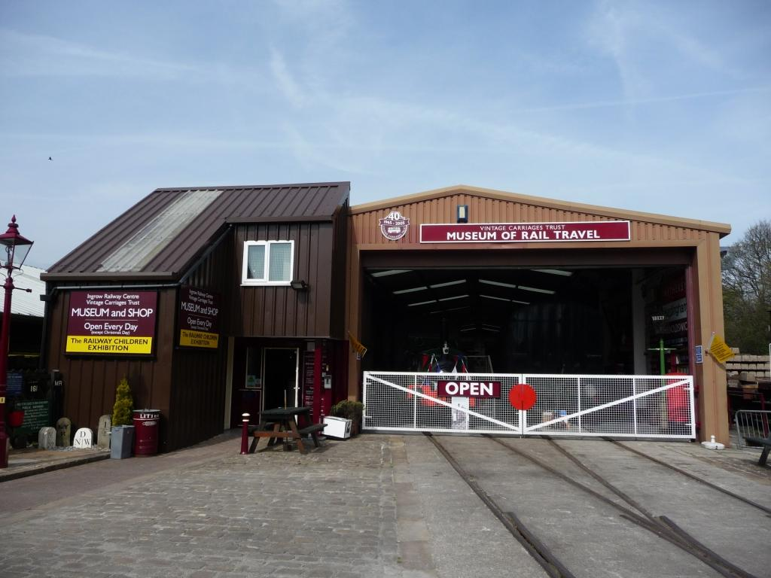
[Delete this picture, insert picture of room from door]
[for caption, insert floor and room name/number]

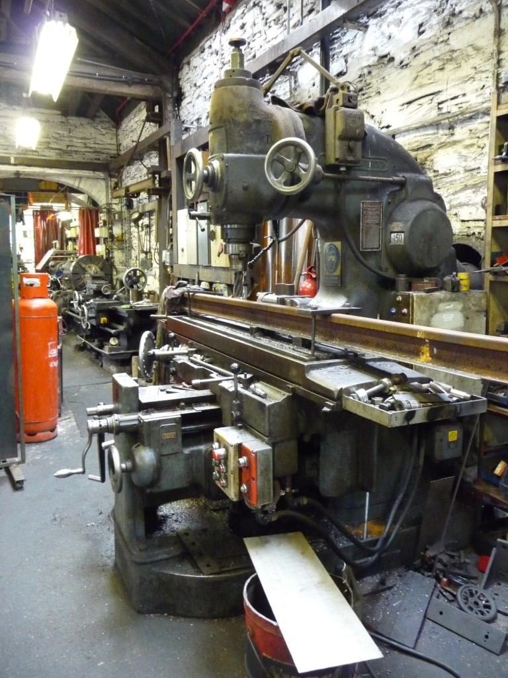
[Delete this picture insert picture of priority object]
[for caption, insert simple object name and unique number]
Priority One, sheet 2 of [insert number], [insert building name]
[insert floor][insert room name / number]
[this is room 3 on the priority list following]

[Delete this picture, insert picture of room from door]
[for caption, insert floor and room name/number]



[Delete these pictures insert pictures of priority objects]
[for caption, insert simple object name and unique number]

[As above for both picture and caption] 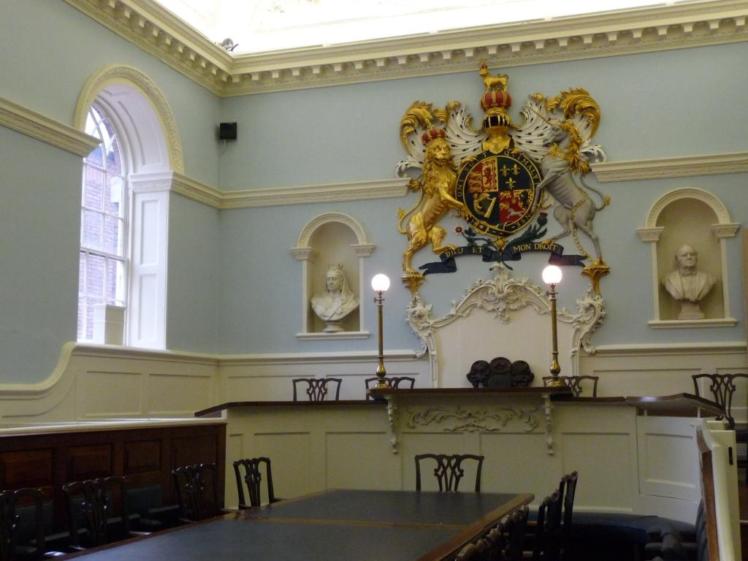
Priority One, sheet 3 of [insert number], [insert building name]
[insert floor][insert room name / number]
[this is room 1 on the priority list following]

[Delete this picture, insert picture of room from door]
[for caption, insert floor and room name/number]

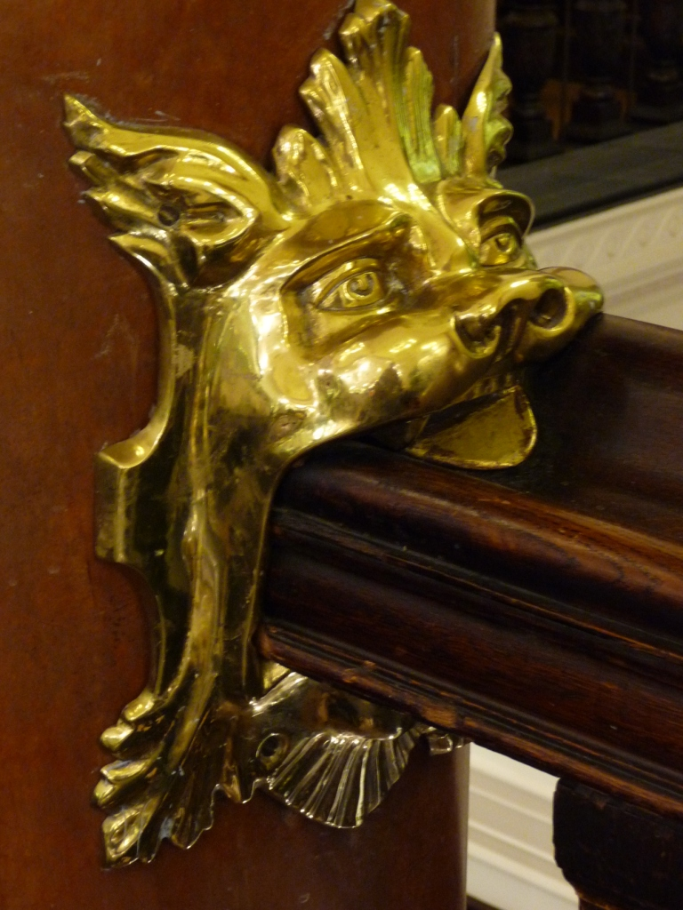

[Delete this picture insert picture of priority object]
[for caption, insert simple object name and unique number]

[insert name of building], Priority List One, Summary Sheet

[insert floor]

Unique number | Description | Location
[1992.213] | [Large bench drill] | [Room 4]
[T 123] | [Meerkat] | [Room 3]
[loan 123] | [Lowell Mill poster] | [Room 3]
- | [Large coat of arms  NOTE – VERY HEAVY. DO NOT MOVE. COVER WITH FIRE BLANKET WHICH IS KEPT IN THE DRAWER BELOW] | [Room 3]
[P2012.123] | [Brass animal head on handrail] | [Room 1]

[These numbers, simple object names and specific instructions are included as examples of good practice only. DELETE and replace with your information.]

[Christine Johnstone, May 2012]

